**Spring Design Reference**

This document is for reference only.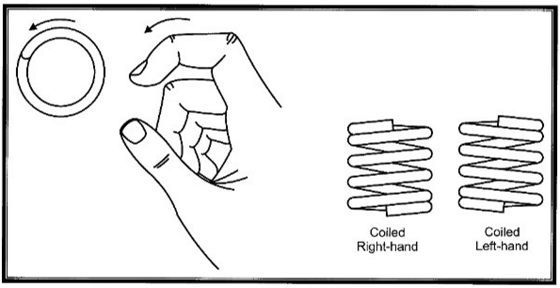

Clockwise

Counter

Clockwise

**Compression Spring End Finishes**

**Spring Dimensions**

